**Task no: 1**

#include <iostream>

using namespace std;

int main() {

int n; // size of the array

cout << "Enter the size of the array: ";

cin >> n;

int arr[n]; // array to store the elements

cout << "Enter the elements of the array: ";

for (int i = 0; i < n; i++) {

cin >> arr[i]; // input the elements

}

int max_count = 0; // maximum frequency of any element

int max_element = -1; // most repeated element

for (int i = 0; i < n; i++) {

int count = 0; // frequency of the current element

for (int j = 0; j < n; j++) {

if (arr[i] == arr[j]) {

count++; // increment the count if the elements are equal

}

}

if (count > max_count) {

max_count = count; // update the maximum frequency

max_element = arr[i]; // update the most repeated element

}

}

cout << "The most repeated element in the array is: " << max_element << endl;

return 0;

}

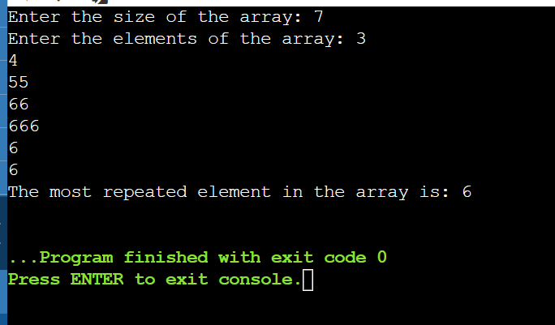

**Task no: 2**

#include <iostream>

using namespace std;

int main()

{

// Declare and initialize the array

int a[8] = {13, 15, 17, 9, 99, 77, 65, 43};

// Declare variables to store the largest and smallest element

int largest = a[0];

int smallest = a[0];

// Loop through the array and compare each element with the current largest and smallest

for (int i = 1; i < 8; i++)

{

if (a[i] > largest)

{

largest = a[i]; // Update the largest element

}

if (a[i] < smallest)

{

smallest = a[i]; // Update the smallest element

}

}

// Print the results

cout << "The largest element is " << largest << endl;

cout << "The smallest element is " << smallest << endl;

return 0;

}

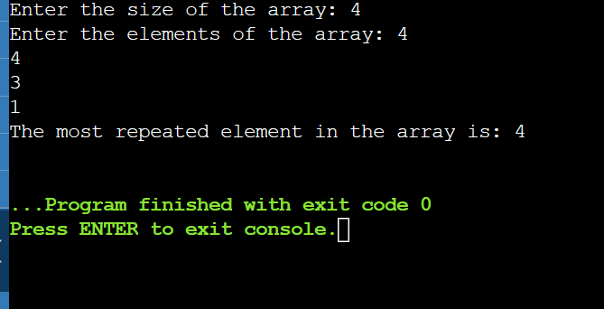

**Task no:3**

#include <iostream>

using namespace std;

int main()

{

// Declare an array of size 5

int arr[5];

// Take 5 array elements from user

cout << "Enter 5 array elements: " << endl;

for (int i = 0; i < 5; i++)

{

cin >> arr[i];

}

// Swap position [2] element with position [4] element

// Use a third variable temp to store the value of arr[2]

int temp = arr[2];

// Assign the value of arr[4] to arr[2]

arr[2] = arr[4];

// Assign the value of temp to arr[4]

arr[4] = temp;

// Display the modified array

cout << "The modified array is: " << endl;

for (int i = 0; i < 5; i++)

{

cout << arr[i] << " ";

}

cout << endl;

return 0;

}

